# CS 255 System Design Document Template

Ty Wheeler

## UML Diagrams

### UML Use Case Diagram

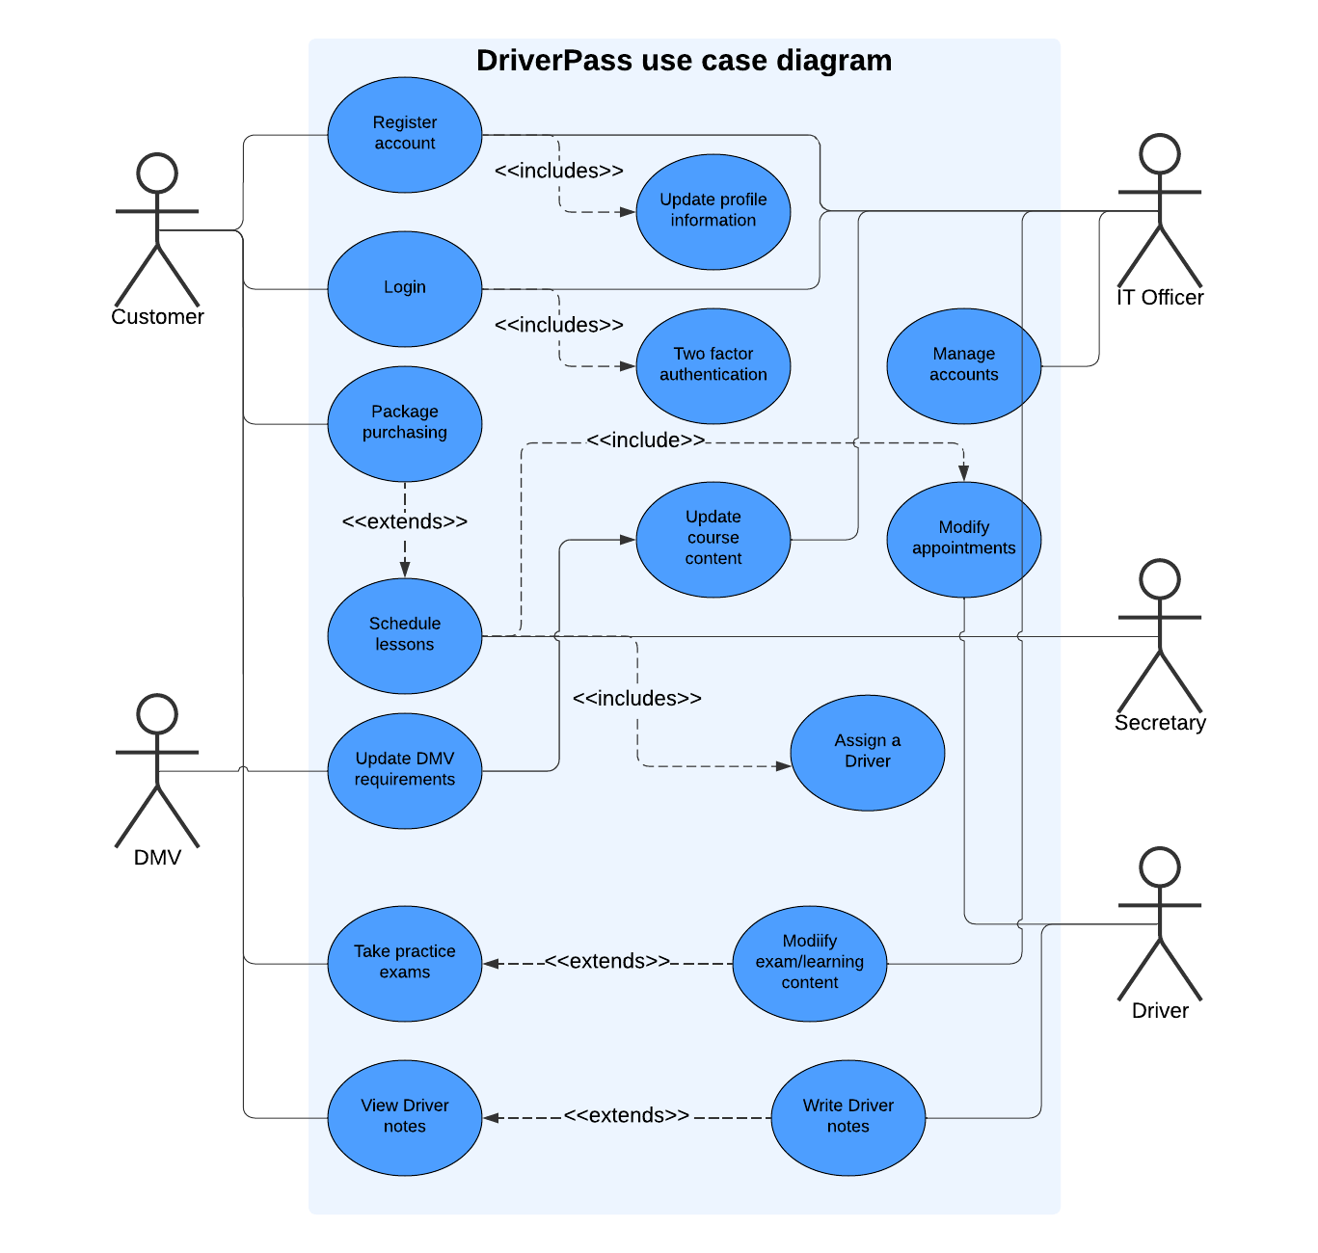

### UML Activity Diagrams

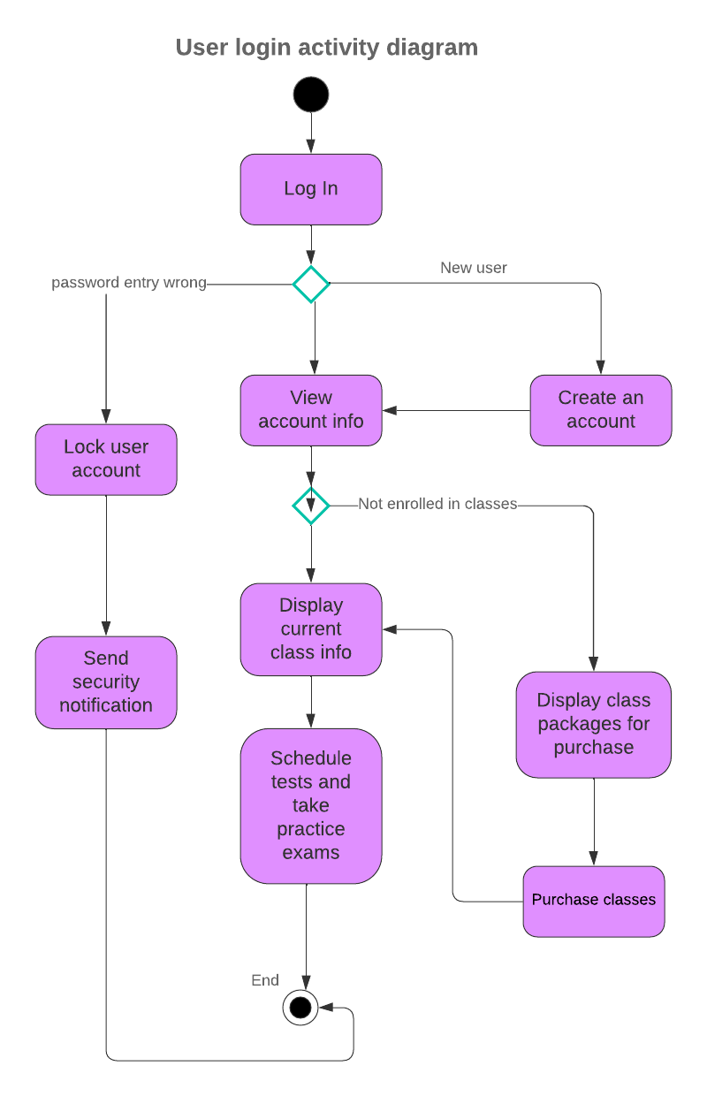

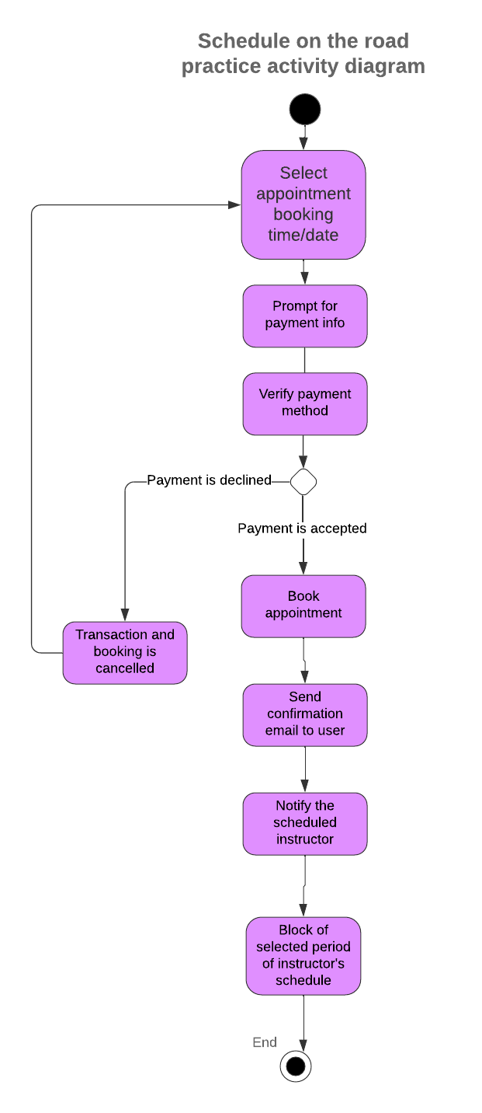

### UML Sequence Diagram

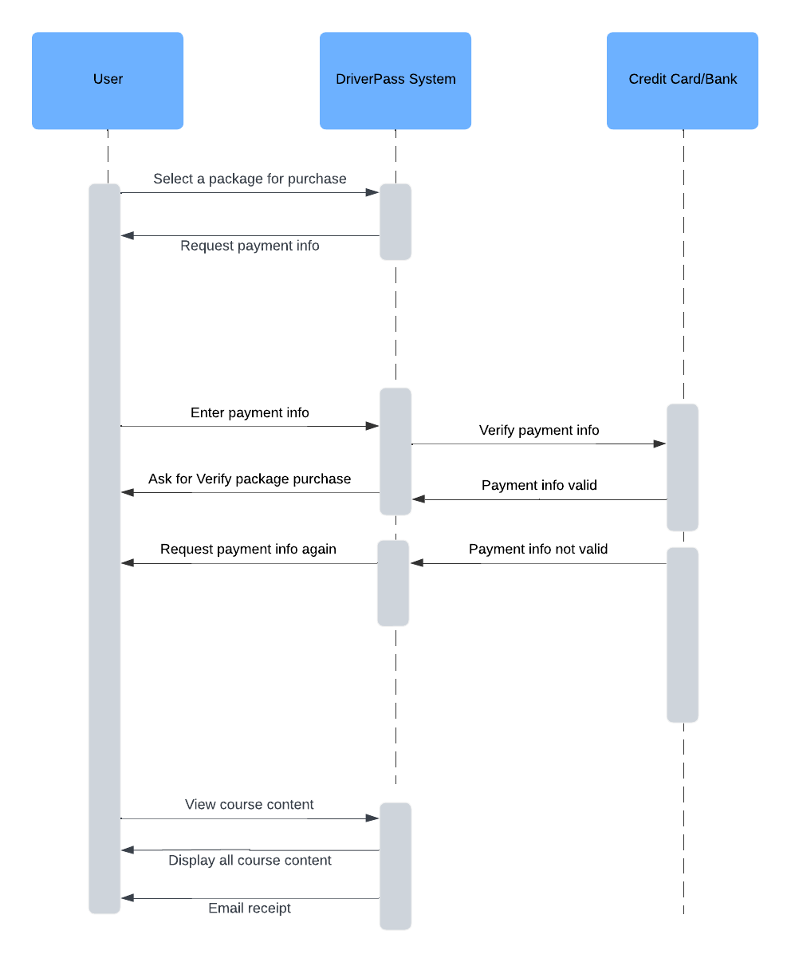

### UML Class Diagram

## Technical Requirements

*[Based on the diagrams you have created, describe the technical requirements of your system. These requirements should address the required hardware, software, tools, and infrastructure necessary for your system design.]*

Based on the system’s requirements there are many components that need to be addressed.

Hardware requirements:

* The system needs reliable and secure servers to host the service.
* The client requires a computer and internet connection in order to connect to the service
* Networking equipment is necessary in order for Driver Pass to maintain the server’s and maintain reliability.

Software requirements:

* The server should run on Windows Server and the client should be utilizing a modern OS such as Windows or macOS.
* A Database Management Systemsuch as MySQL should be used to manage the system's data.
* A web server such as Apache is needed to host the web application, providing access to all of the system's functionality.
* The system will be developed using modern programming languages such as JavaScript or C++ and use IDE’s like Visual Studio Code.
* Encryption tools are also needed such as SSL/TLS certificates for secure communication.

Tools & Infrastructure:

* A version control system like Git is needed for managing code versions and collaborating with team members.
* Regular backups of the database and system’s files should be automated using backup tools. These backups should be stored offsite or in secure cloud storage.